SAVE KULALUK FOR ALL THE COMMUNITY!
When will the Kulaluk leaseholders stop their greedy plans to sell the Kulaluk land? So far the Gwalwa Daraniki Association (GDA) has agreed to the Redco canal housing estate in 1981, the Vysrose theme park and golf course along Bagot Road in 1996, the prawn and crab farm, the Arafura Harbour marina and several other destructive schemes. All have failed because they went broke or the area is in the flight path or because Aboriginal people and their friends have strongly opposed alienating the Kulaluk land. The land is more valuable for its priceless social, environmental and cultural values. Unfortunately the earth dump on Dickward Drive has now been zoned light industrial. This must also be stopped!
According to the attached report, “Our Vision of Economic Independence”, the one “valuable asset” the GDA members have is “their land as a bargaining tool to build economic independence”. The report claims that money-making opportunities were “somewhat limited due to some parts of the area being mainly mangrove swamp lands and also being in the flight path of the Darwin International Airport”. The report adds that today Kulaluk is “seen as prime real estate by the wider Darwin community for commercial ventures and is very much sought after which may result in further economic independence for the community in the near future”. [The so-called ‘wider community’ might disagree!]
Under the brief heading, “Social”, the report describes how Kulaluk is near shopping centres, and “within walking distance to the sea and beautiful beaches”. The report sounds like an advertisement with no mention of why the land is important to Aboriginal people, except that the crab farm will “provide participants with scientific farming skills as well as incorporating their own natural skills as hunters and gatherers”. Unfortunately because of the prawn/crab farm, large parts of the Kulaluk land have been locked away since 1997 with signs saying “No Trespassing - Private Property” stopping the families who gather yams, mangrove crabs and shellfish or go spearing or fishing on the tidal flats or along the beach.
The report does not mention why the land was returned to Aboriginal people after eight years of struggle or discuss how the commercial ventures will affect the people who have traditionally used the land. It only writes about the land as a money making asset, never as a social and culturally asset. Nor does the report say why many people fought and died to win back the land.
At least the report tells us who are the “stakeholders” responsible for the financial, social and environmental disaster that is the crab farm, using ponds designed for a prawn farm. Both are now bankrupted and valuable equipment lies around the abandoned transportable buildings with papers scattered in the vandalised office. Powerlines lead to nowhere. No one has accepted responsibility for this waste of public money. The attached report suggests why the project was bound to fail and who is implicated.
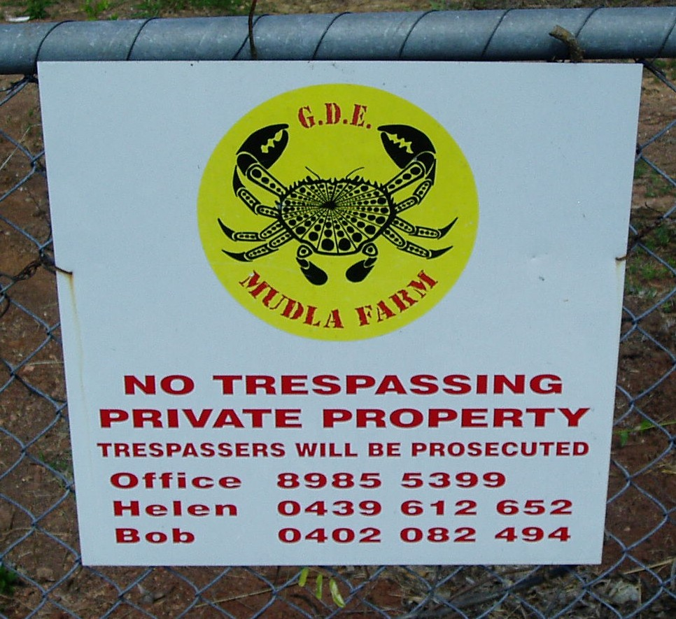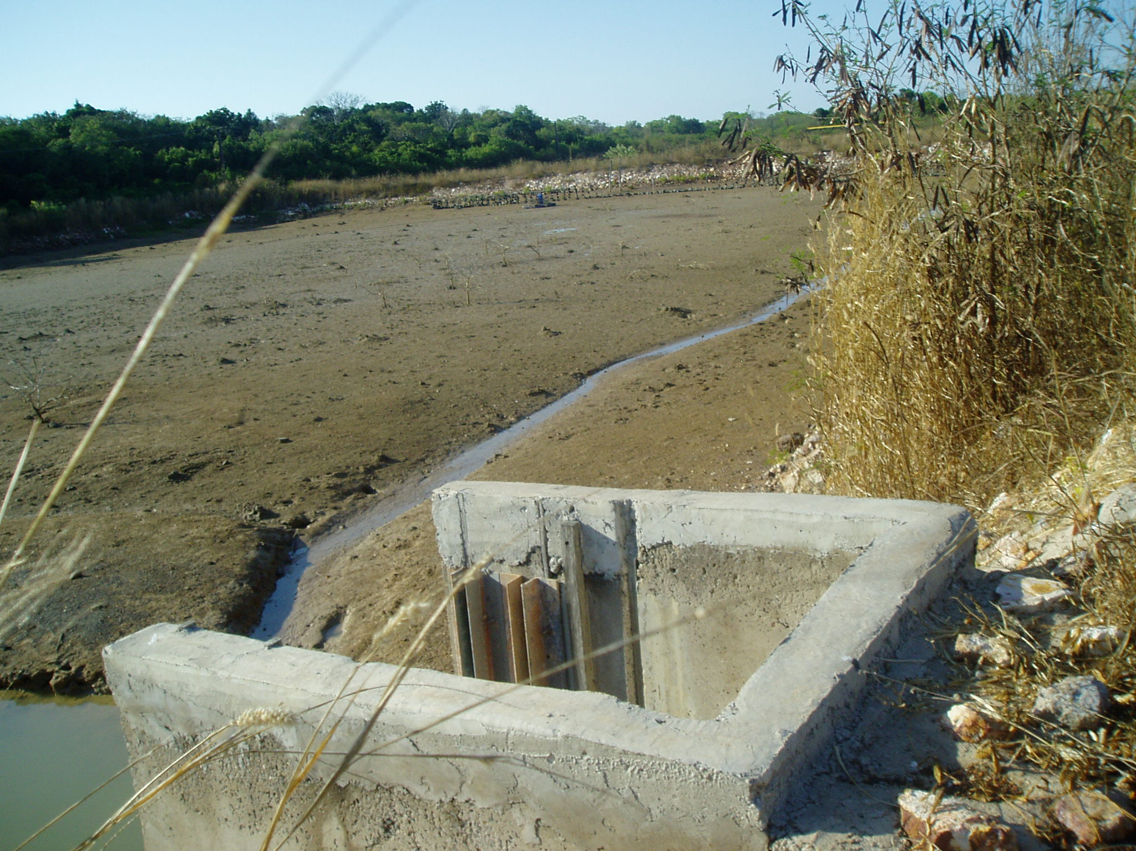
Above: A sign at the Totem Road entrance to the lease discourages Aborigines and the general public from entering the Kulaluk lease.
Right: One of the abandoned ponds. The permit states that the area must be restored if the project(s) fail but now there are plans to turn the ponds into “a rowing course”

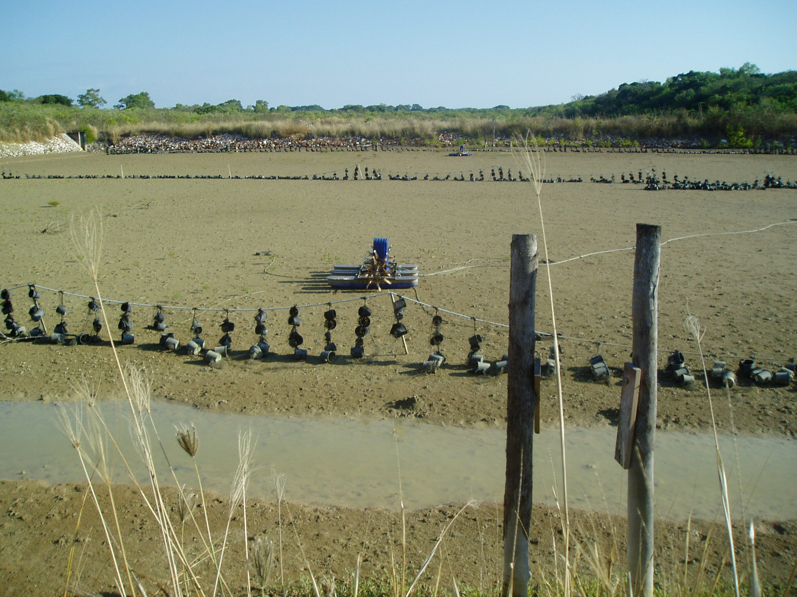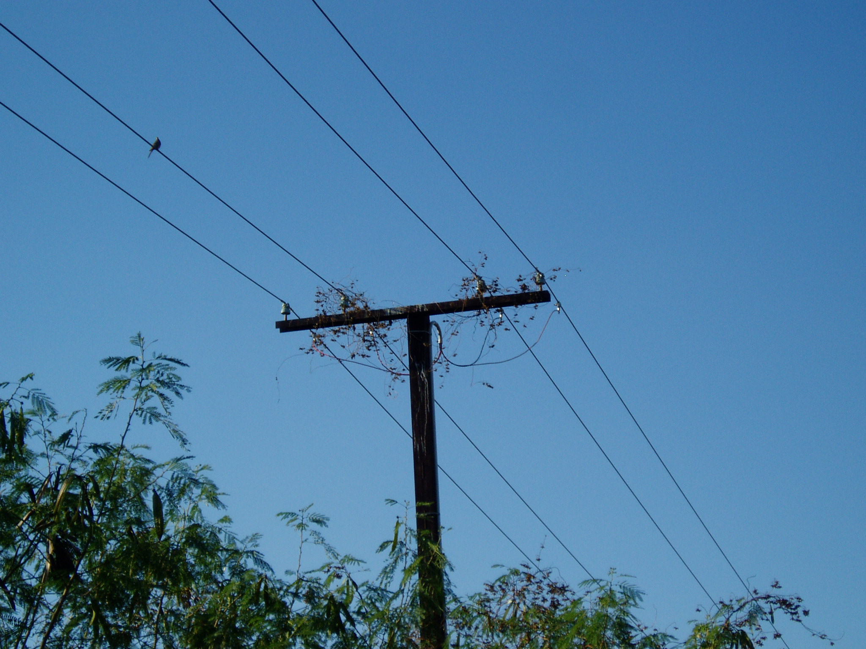
Above left: Equipment for crab breeding lies in the mud of the abandoned and overgrown ponds. According to the report, the crabs had to be fed three times every 24 hours. Right: Power lines on the Kulaluk lease now lead to nowhere.

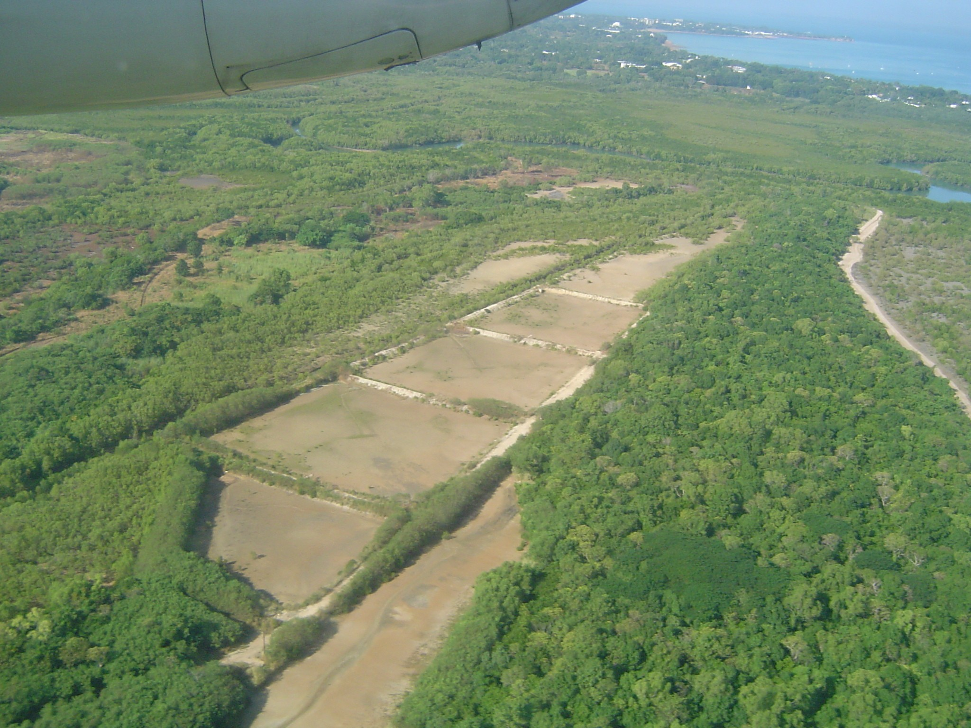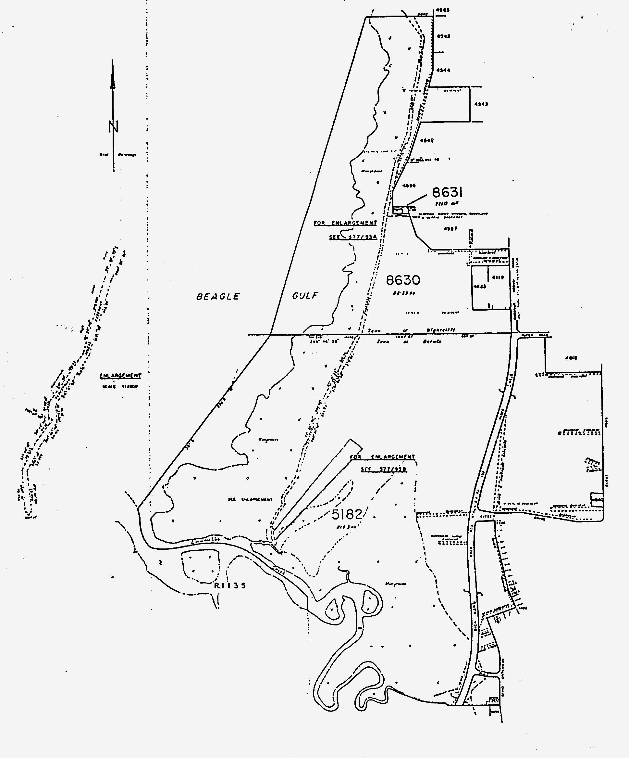
Above: The ponds with Fannie Bay in the background. Right: Map of the lease showing aquaculture ponds beside Ludmilla Creek. Now the GDA want to turn the area into a one billion dollar marina canal housing estate so the millionaire buyers can tie up their super yachts in front of their big houses!

